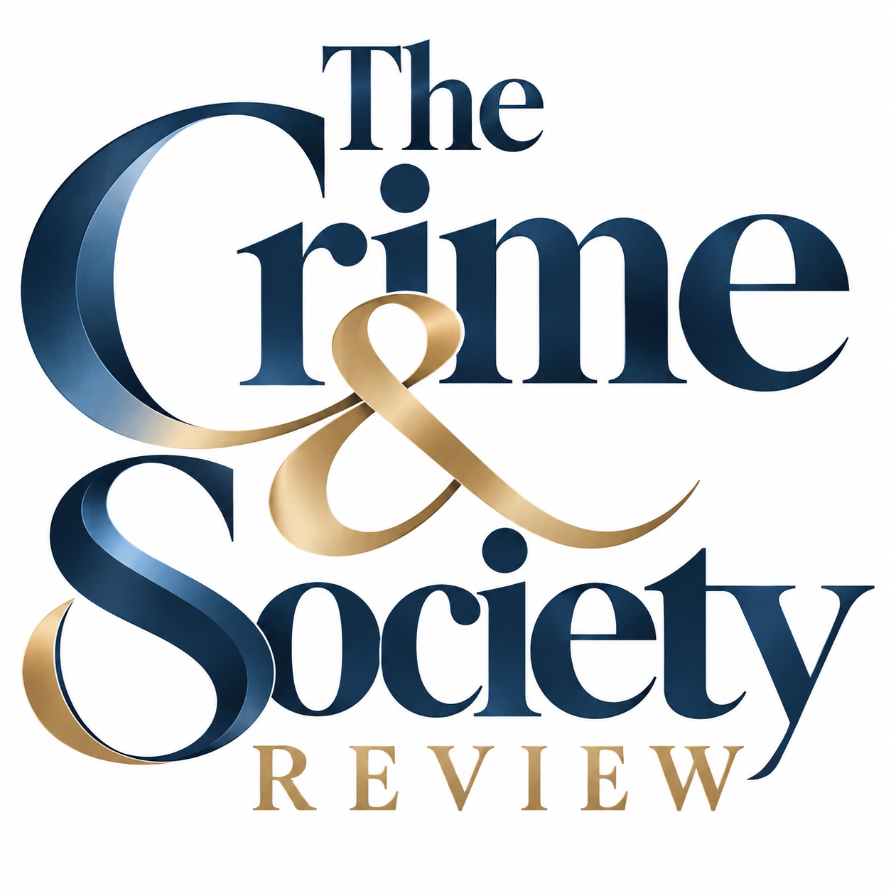

THE CRIME & SOCIETY REVIEW
ABOUT THE CRIME & SOCIETY REVIEW
The Crime & Society Review is an interdisciplinary academic rolling publication journal dedicated to advancing critical, evidence-based, and multidimensional understandings of crime, criminality, victimisation, justice, and their wider implications for society. The journal recognises that crime is rarely a phenomenon that can be adequately understood through a single disciplinary lens. Drawing upon the Rashomon Effect as a conceptual inspiration, The Crime & Society Review seeks to examine crime through multiple perspectives, recognising that different disciplines, stakeholders, and forms of evidence may reveal distinct yet interconnected dimensions of the same phenomenon. It therefore welcomes rigorous scholarship exploring the criminological, forensic, psychological, legal, sociological, technological, behavioural, philosophical, historical, and policy dimensions of crime and criminal justice. The journal provides a platform for original research, blogs, theoretical contributions, empirical studies, methodological innovations, conceptual analyses, and interdisciplinary insights that contributes to a deeper understanding of how crime is committed, experienced, investigated, explained, regulated, and represented. Particular emphasis is placed on the scientific reasoning and evidentiary foundations underlying crime and criminal behaviour, while also considering the roles of institutions, communities, victims, offenders, technology, law-enforcement agencies, forensic practitioners, policymakers, and society at large. The journal encourages scholarship that develops or critically examines concepts, theories, models, frameworks, methodologies, and philosophies relevant to the study of crime and society. With its broad interdisciplinary orientation, The Crime & Society Review aims to bridge disciplinary boundaries and encourage meaningful dialogue between researchers and practitioners across criminology, criminal justice, forensic science, psychology, law, sociology, anthropology, political science, cybersecurity, behavioural sciences, victimology, penology, and allied fields. The journal particularly values research that challenges conventional assumptions, connects seemingly distinct perspectives, integrates diverse forms of evidence, and offers nuanced explanations of complex crime-related phenomena. By bringing together multiple ways of seeing, questioning, and interpreting crime, The Crime & Society Review aspires to contribute to a more comprehensive and scientifically grounded understanding of crime, justice, and society.
AIMS & SCOPE
The Crime & Society Review is an interdisciplinary scholarly journal committed to advancing the systematic, critical, and evidence-informed study of crime, criminality, victimisation, criminal justice, and their complex relationship with society. The journal seeks to provide a scholarly platform for research that moves beyond disciplinary boundaries and examines crime as a multidimensional phenomenon shaped by individual, social, legal, institutional, technological, psychological, cultural, economic, and environmental factors. It welcomes original empirical research, theoretical contributions, conceptual scholarship, methodological studies, systematic and critical reviews, and interdisciplinary analyses that contribute substantively to the understanding of crime and its associated processes. The scope of the journal encompasses, but is not limited to, criminology, criminal justice, policing, forensic science, forensic psychology, law and legal studies, sociology, victimology, penology, corrections, crime prevention, cybercrime, cybersecurity, behavioural sciences, criminal investigation, organised crime, terrorism and extremism studies, juvenile justice, gender and crime, and emerging forms of criminality. Particular value is placed on scholarship that develops or critically engages with theories, concepts, models, frameworks, methodologies, and philosophies, as well as research that translates knowledge into meaningful implications for justice institutions, professional practice, public policy, and society. Through this broad scope, the journal seeks to build rigorous scholarship capable of explaining not only what crime is and how it occurs, but also why it emerges, how it is experienced and investigated, how it is regulated and represented, and what its consequences are for individuals, institutions, and society.
EDITORIAL PHILOSOPHY
The editorial philosophy of The Crime & Society Review is grounded in the principles of intellectual rigour, methodological integrity, inter-disciplinarity, critical inquiry, and scholarly openness. The journal recognises that meaningful knowledge about crime cannot be produced through methodological or disciplinary exclusivity; rather, complex crime-related phenomena often require the integration of diverse theories, forms of evidence, methodological traditions, and analytical perspectives. Accordingly, the journal encourages scholarship that is theoretically informed, methodologically transparent, empirically grounded, and critically engaged with existing knowledge. It values both established and emerging approaches where they demonstrate scholarly merit and contribute to advancing understanding. The journal also encourages researchers to question assumptions, examine competing explanations, identify gaps in existing frameworks, and explore the implications of their findings beyond conventional disciplinary boundaries. Editorial assessment is therefore guided by the quality, originality, relevance, transparency, and scholarly contribution of a submission rather than by disciplinary labels alone. The Crime & Society Review is committed to nurturing a scholarly environment in which disagreement can coexist with academic respect, unconventional questions can receive serious consideration, and evidence and reason remain central to the production and evaluation of knowledge.
MULTIDISCIPLINARY PERSPECTIVE / RASHOMON APPROACH
At the intellectual core of The Crime & Society Review is its multidisciplinary perspective, conceptually informed by what may be described as the Rashomon Approach - the recognition that a single phenomenon may be observed, interpreted, experienced, and explained differently depending upon the perspective, position, evidence, and analytical framework through which it is examined. In the study of crime, the same event may simultaneously represent a criminal act from a legal perspective, a behavioural phenomenon from a psychological perspective, an evidentiary problem from a forensic perspective, a social process from a sociological perspective, an institutional challenge from a policing perspective, and an experience of harm from a victimological perspective. These perspectives need not be treated as mutually exclusive; rather, their intersection can produce a more nuanced and comprehensive understanding of the phenomenon under investigation. The journal therefore encourages scholarship that brings together multiple disciplinary lenses, stakeholders, methodologies, and forms of evidence while remaining attentive to their respective assumptions and limitations. The Rashomon Approach is not intended to suggest that all interpretations possess equal evidentiary validity; instead, it invites researchers to examine how different perspectives contribute to, complement, challenge, or complicate the explanation of crime and justice. Through this orientation, The Crime & Society Review seeks to transform multiple perspectives into deeper inquiry, encouraging scholarship that looks beyond a single account to examine the wider constellation of factors through which crime is understood.
JOURNAL HISTORY
The Crime & Society Review was conceived from the recognition that contemporary crime increasingly transcends conventional disciplinary boundaries and demands forms of inquiry capable of connecting criminological theory with scientific evidence, legal frameworks, forensic investigation, human behaviour, social structures, technological change, and institutional practice. The journal was established with the vision of creating an inclusive yet rigorous scholarly forum where researchers, academics, practitioners, and other knowledge contributors can engage with crime and society from diverse intellectual and methodological standpoints. Its development is guided by the belief that the evolving nature of crime requires scholarship that is not confined to established categories but remains responsive to emerging forms of criminality, new technologies, changing social realities, and developments in criminal justice. As the journal evolves, its history will be shaped by the scholarship it publishes, the intellectual communities it brings together, and its contribution to developing knowledge across the interconnected fields of crime, justice, and society. The journal remains committed to maintaining an evolving scholarly identity while preserving its foundational principle: to examine crime through multiple perspectives and pursue a deeper understanding through rigorous academic inquiry.
PUBLISHER
The Crime & Society Review is published by The Crime & Society Review, which provides the institutional and scholarly framework supporting the journal's academic mission. The publisher is committed to promoting rigorous research, interdisciplinary scholarship, ethical publishing practices, and the responsible dissemination of knowledge. Through the journal, the institution seeks to contribute to wider academic and professional conversations concerning crime, criminal justice, law, forensic and behavioural sciences, policing, technology, and society. The journal operates with a commitment to scholarly independence, research integrity, transparency, and internationally recognised principles of academic publishing. Its institutional foundation provides an environment for bringing together researchers and practitioners from diverse disciplines and geographical contexts, facilitating the exchange of evidence, ideas, methodologies, and perspectives. As the journal develops, the publisher/institution aims to support its growth as a credible scholarly platform while ensuring that editorial decisions remain guided by academic quality, integrity, relevance, and the contribution of published work to the advancement of knowledge.

